®  34-36 Peyo Yavorov blvd,  Sofia 1164, Bulgaria | tel +359 2 423 4455  proektsoft.bg@gmail.com  https://calcpad.eu

A CALCPAD PROGRAM

FOR ANALYSIS OF PLANE FRAMES
WITH ARBITRARY CROSS-SECTIONS

─◊─◊──◊───◊────⧫────◊───◊──◊─◊─

(using the finite element method)

by

Eng. Nedelcho Ganchovsky
Table of Contents
I. Introduction 2
II. Calcpad source code 3
III. Output 13
IV. Comparison with Stadyps 6.0 software 20

Introduction
This Calcpad program calculates plane frames with arbitrary sections using the finite element method. The input data is entered in text format as vectors and matrices as follows:
- joint coordinates;
- joint numbers at the ends of the elements;
- material properties;
- dimensions and types of cross-sections;
- support conditions;
- load values.
As a result, diagrams of internal forces and deflections of structural elements are obtained. The schemes are automatically generated by the program, using the SVG graphical format.

Calcpad source code
1  2  3  4  5  6  7  8  9  10  11  12  13  14  15  16  17  18  19  20  21  22  23  24  25  26  27  28  29  30  31  32  33  34  35  36  37  38  39  40  41  42  43  44  45  46  47  48  49  50  51  52  53  54  55  56  57  58  59  60  61  62  63  64  65  66  67  68  69  70  71  72  73  74  75  76  77  78  79  80  81  82  83  84  85  86  87  88  89  90  91  92  93  94  95  96  97  98  99  100  101  102  103  104  105  106  107  108  109  110  111  112  113  114  115  116  117  118  119  120  121  122  123  124  125  126  127  128  129  130  131  132  133  134  135  136  137  138  139  140  141  142  143  144  145  146  147  148  149  150  151  152  153  154  155  156  157  158  159  160  161  162  163  164  165  166  167  168  169  170  171  172  173  174  175  176  177  178  179  180  181  182  183  184  185  186  187  188  189  190  191  192  193  194  195  196  197  198  199  200  201  202  203  204  205  206  207  208  209  210  211  212  213  214  215  216  217  218  219  220  221  222  223  224  225  226  227  228  229  230  231  232  233  234  235  236  237  238  239  240  241  242  243  244  245  246  247  248  249  250  251  252  253  254  255  256  257  258  259  260  261  262  263  264  265  266  267  268  269  270  271  272  273  274  275  276  277  278  279  280  281  282  283  284  285  286  287  288  289  290  291  292  293  294  295  296  297  298  299  300  301  302  303  304  305  306  307  308  309  310  311  312  313  314  315  316  317  318  319  320  321  322  323  324  325  326  327  328  329  330  331  332  333  334  335  336  337  338  339  340  341  342  343  344  345  346  347  348  349  350  351  352  353  354  355  356  357  358  359  360  361  362  363  364  365  366  367  368  369  370  371  372  373  374  375  376  377  378  379  380  381  382  383  384  385  386  387  388  389  390  391  392  393  394  395  396  397  398  399  400  401  402  403  404  405  406  407  408  409  410  411  412  413  414  415  416  417  418  419  420  421  422  423  424  425  426  427  428  429  430  431  432  433  434  435  436  437  438  439  440  441  442  443  444  445  446  447  448  449  450  451  452  453  454  455  456  457  458 | #include svg_drawing.cpd  "Analysis of plane frames with arbitrary cross-sections  '<h4>Joint coordinates - xJ; yJ</h4>  #hide  #deg  δz = 10^-12  Precision = 10^-9  x_J = [0; 0; 8; 16; 16]*m  y_J = [0; 8; 10; 8; 0]*m  #show  x_J','y_J  n_J = len(x_J)  '<h4>Elements - [J1; J2]</h4>  #hide  e_J = [1; 2|2; 3|3; 4|4; 5]  #show  transp(e_J)  n_E = n_rows(e_J)  'Element endpoint coordinates  x_1(e) = x_J.e_J.(e; 1)','y_1(e) = y_J.e_J.(e; 1)  x_2(e) = x_J.e_J.(e; 2)','y_2(e) = y_J.e_J.(e; 2)  'Element length - 'l(e) = sqrt((x_2(e) - x_1(e))^2 + (y_2(e) - y_1(e))^2)  'Element direction  c(e) = (x_2(e) - x_1(e))/l(e)','s(e) = (y_2(e) - y_1(e))/l(e)  'Transformation matrix  'Diagonal 3x3 block -'t(e) = [c(e); s(e); 0|-s(e); c(e); 0|0; 0; 1]  'Generation of the full transformation matrix  T(e) = add(t(e); add(t(e); matrix(6; 6); 1; 1); 4; 4)  '<h4>Supports - [Joint; cx; cy; cr]</h4>  #hide  c = [1; 10^20kN/m; 10^20kN/m; 0kNm|5; 10^20kN/m; 10^20kN/m; 10^20kNm]  #show  c  n_c = n_rows(c)  '<h4>Loads - [Element, qx, qy]</h4>  #hide  q = [1; 10kN/m; 0kN/m|2; 0kN/m; -20kN/m|3; 0kN/m; -10kN/m]  n_q = n_rows(q)  q_x = vector(n_E)*kN/m  q_y = vector(n_E)*kN/m  $Repeat{q_x.(q.(i; 1)) = q_x.(q.(i; 1)) + q.(i; 2) @ i = 1 : n_q}  $Repeat{q_y.(q.(i; 1)) = q_y.(q.(i; 1)) + q.(i; 3) @ i = 1 : n_q}  #show  q  'Load values on elements  q_x  q_y  '<h4>Scheme of the structure</h4>  #hide  w = max(x_J)  h = max(y_J)  W = 240  H = h*W/w  k = W/w  #def svg$ = '<svg viewbox="'-3m*k' '-2m*k' '(w + 6m)*k' '(h + 4m)*k'" xmlns="http://www.w3.org/2000/svg" version="1.1" style="font-family: Georgia Pro; font-size:4pt; width:'W + 150'pt; height:'H + 200*H/W'pt">  #def thin_style$ = style = "stroke:green; stroke-width:1; fill:none"  #def thick_style$ = style = "stroke:green; stroke-width:2; fill:none"  k_q = m/kN  #show  #val  svg$  #for i = 1 : n_E  #hide  x1 = x_1(i)*k  y1 = (h - y_1(i))*k  x2 = x_2(i)*k  y2 = (h - y_2(i))*k  q_xi = q_x.i  q_yi = q_y.i  α = atan2(c(i); s(i))  #if α ≥ 135  α = α - 180  #end if  #if α < -45  α = α + 180  #else if α < 0  α = 360 + α  #end if  #if q_xi ≠ 0kN/m  #hide  x3 = x2 - q_xi*k_q','y3 = y2  x4 = x1 - q_xi*k_q','y4 = y1  x = (x3 + x4)/2 - 5*sign(q_xi)  y = (y3 + y4)/2  #show  '<polygon points="'x1','y1' 'x2','y2' 'x3','y3' 'x4','y4'" style="stroke:magenta; stroke-width:1; stroke-opacity:0.3; fill:magenta; fill-opacity:0.1;" />  text$(x;y;α;qx='abs(q_xi)')  #end if  #if q_yi ≠ 0kN/m  #hide  x3 = x2','y3 = y2 + q_yi*k_q  x4 = x1','y4 = y1 + q_yi*k_q  x = (x3 + x4)/2  y = (y3 + y4)/2 + 5*sign(q_yi)  #show  '<polygon points="'x1','y1' 'x2','y2' 'x3','y3' 'x4','y4'" style="stroke:dodgerblue; stroke-width:1; stroke-opacity:0.4; fill:dodgerblue; fill-opacity:0.15;" />  text$(x;y;α;qy='abs(q_yi)')  #end if  #show  line$(x1; y1; x2; y2; main_style$)  #loop  '<g id="frame">  #for i = 1 : n_E  #hide  x1 = x_1(i)*k  y1 = (h - y_1(i))*k  x2 = x_2(i)*k  y2 = (h - y_2(i))*k  #show  line$(x1; y1; x2; y2; main_style$)  #loop  #for i = 1 : n_c  #hide  j = c.(i; 1)  x1 = x_J.j*k  y1 = (h - y_J.j)*k  δ = w/30*k*sign(x1 - w/2*k)  x2 = x1 - δ  y2 = y1 - abs(δ)  x3 = x1 + δ  y3 = y1 + abs(δ)  #show  #if c.(i; 2) ≠ 0kN/m  #if c.(i; 3) ≠ 0kN/m  #if c.(i; 4) ≠ 0kNm  line$(x1; y1; x1; y3; thin_style$)  line$(x2; y3; x3; y3; thick_style$)  #else  line$(x2; y3; x3; y3; thick_style$)  line$(x2; y3; x1; y1; thin_style$)  line$(x3; y3; x1; y1; thin_style$)  #end if  #else  #if c.(i; 4) ≠ 0kNm  line$(x1; y1; x2; y1; thin_style$)  line$(x2; y2; x2; y3; thick_style$)  line$(x2 - δ/2; y2; x2 - δ/2; y3; thick_style$)  #else  line$(x2; y2; x1; y1; thin_style$)  line$(x2; y3; x1; y1; thin_style$)  line$(x2; y2; x2; y3; thin_style$)  line$(x2 - δ/2; y2; x2 - δ/2; y3; thick_style$)  #end if  #end if  #else  #if c.(i; 3) ≠ 0kN/m  #if c.(i; 4) ≠ 0kNm  line$(x1; y1; x1; y3; thin_style$)  line$(x2; y3; x3; y3; thick_style$)  line$(x2; y3 + abs(δ)/2; x3; y3 + abs(δ)/2; thick_style$)  #else  line$(x2; y3; x3; y3; thin_style$)  line$(x2; y3; x1; y1; thin_style$)  line$(x3; y3; x1; y1; thin_style$)  line$(x2; y3 + abs(δ)/2; x3; y3 + abs(δ)/2; thick_style$)  #end if  #else  line$(x2; y2; x3; y3; thick_style$)  #end if  #end if  #loop  '</g>  #for i = 1 : n_E  #hide  x = (x_1(i) + x_2(i))*k/2  y = (h - (y_1(i) + y_2(i))/2)*k  #show  texth$(x + 0.8m*sign(W/2 - x)*k; y + 0.6m*k; e'i')  #loop  #for i = 1 : n_J  point$(x_J.i*k; (h - y_J.i)*k; point_style$)  texth$((x_J.i - 0.7m*sign(w/2 - x_J.i))*k; (h - y_J.i - 0.4m)*k; J'i')  #loop  dimv$((w + 2m)*k; (h - y_J.4)*k; h*k; 'y_J.4')  dimv$((w + 2m)*k; 0; (h - y_J.4)*k; 'h - y_J.4')  dimh$(0; w*k; (h + 1.5m)*k; 'w')  '</svg>  #equ  '<h4>Materials</h4>  'Modules of elasticity -'E = [45; 35]*GPa  'Poisson coefficients -'ν = [0.2; 0.2]  'Shear modules -'G = E/(2*(1 + ν))  'Assignment on elements -'e_M = [1; 2; 2; 1]  '<h4>Cross-sections</h4>  #hide  b = vector(2)','h = vector(2)  #show  'Section S1 -'h.1 = 500mm'- circular - 'b_C(z) = 2*sqrt((h.1/2)^2 - (z - h.1/2)^2)  'Section S2 -'b.2 = 250mm','h.2 = 700mm'- rectangular -'b_R(z) = b.2  'General representation -'b(z; s) = take(s; b_C(z); b_R(z))  '<h4>Cross section properties</h4>  'Equations  'Area -'A(s) = $Integral{b(z; s) @ z = 0mm : h.s}  'First moment of area -'S(s) = $Integral{b(z; s)*z @ z = 0mm : h.s}|cm^3  'Centroid -'z_c(s) = S(s)/A(s)|mm  'Second moment of area -'I(s) = $Integral{b(z; s)*(z - z_c(s))^2 @ z = 0mm : h.s}  'First moment of area below z -'S_1(z; s) = $Integral{b(ζ; s)*(z_c(s) - ζ) @ ζ = 0mm : z}  'Shear area -'A_s(s) = I(s)^2/$Integral{S_1(z; s)^2/b(z; s) @ z = 0mm : h.s}  'Calculated results  'Centroids -'z_c = [z_c(1); z_c(2)]  'Areas -'A = [A(1); A(2)]  'Shear areas -'A_s = [A_s(1); A_s(2)]  'Second moments of area -'I = [I(1); I(2)]  'Assignment on elements -'e_S = [1; 2; 2; 1]  '<h4>Element stiffness matrix</h4>  'Elastic properties for element "e"  EA(e) = E.e_M.e*A.e_S.e  EI(e) = E.e_M.e*I.e_S.e  GA_s(e) = G.e_M.e*A_s.e_S.e  k_s(e) = 12*EI(e)/(GA_s(e)*l(e)^2)  α(e) = EA(e)/l(e)','β(e) = EI(e)/(l(e)^3*(1 + k_s(e)))  'Stiffness matrix coefficients for element "e"  k_11(e) = α(e)*(m/kN)','k_22(e) = 12*β(e)*(m/kN)','k_23(e) = 6*β(e)*l(e)*(1/kN)  k_33(e) = (4 + k_s(e))*β(e)*l(e)^2*(1/kNm)  k_36(e) = (2 - k_s(e))*β(e)*l(e)^2*(1/kNm)  'Assembling the 3x3 stiffness matrix blocks for element "e"  k_ii(e) = [k_11(e)|0; k_22(e); k_23(e)|0; k_23(e); k_33(e)]  k_ij(e) = [-k_11(e)|0; -k_22(e); k_23(e)|0; -k_23(e); k_36(e)]  k_ji(e) = transp(k_ij(e))  k_jj(e) = [k_11(e)|0; k_22(e); -k_23(e)|0; -k_23(e); k_33(e)]  'Full 6x6 element stiffness matrix  k_E(e) = stack(augment(k_ii(e); k_ij(e)); augment(k_ji(e); k_jj(e)))  'Stiffness matrices obtained in local coordinates  k_E(1)  k_E(2)  'Stiffness matrices obtained in global coordinates  transp(T(1))*k_E(1)*T(1)  transp(T(2))*k_E(2)*T(2)  '<h4>Global stiffness matrix</h4>  #hide  K = symmetric(3*n_J)  'Add element stiffness matrices  #for e = 1 : n_E  i = 3*e_J.(e; 1) - 2','j = 3*e_J.(e; 2) - 2  t = t(e)','tT = transp(t)  add(tT*k_ii(e)*t; K; i; i)  #if j > i  add(tT*k_ij(e)*t; K; i; j)  #else  add(tT*k_ji(e)*t; K; j; i)  #end if  add(tT*k_jj(e)*t; K; j; j)  #loop  'Add supports  #for i = 1 : n_c  j = 3*c.(i; 1) - 2  add(vec2diag(last(row(c; i); 3)/[kN/m; kN/m; kNm]); K; j; j)  #loop  #show  K  '<h4>Element load vector</h4>  'Lateral load in local CS -'q_E(e) = -q_x.e*s(e) + q_y.e*c(e)  'Axial load in local CS -'n_E(e) = q_x.e*c(e) + q_y.e*s(e)  'Equivalent loads at element endpoints  F_Ex(e) = q_x.e*l(e)/2*(1/kN)','F_Ey(e) = q_y.e*l(e)/2*(1/kN)  M_E(e) = q_E(e)*l(e)^2/12*(1/kNm)  'Load vector -'F_E(e) = [F_Ex(e); F_Ey(e); M_E(e); F_Ex(e); F_Ey(e); -M_E(e)]  #novar  'Results for elements  #for e = 1 : n_E  'Element Е'e' -'F_E(e)  #loop  #varsub  '<h4>Global load vector</h4>  #hide  F = vector(3*n_J)  #for i = 1 : n_q  e = q.(i; 1)  #for jj = 1 : 2  j = 3*e_J.(e; jj) - 3  F.(j + 1) = F.(j + 1) + take(3*jj - 2; F_E(e))  F.(j + 2) = F.(j + 2) + take(3*jj - 1; F_E(e))  F.(j + 3) = F.(j + 3) + take(3*jj; F_E(e))  #loop  #loop  #show  F  '<h4>Results</h4>  '<p><strong>Solution of the system of equations by Cholesky decomposition </strong></p>  Z = clsolve(K; F)  '<p><strong>Joint displacements</strong></p>  z_J(j) = slice(Z; 3*j - 2; 3*j)  z(j) = round(z_J(j)/δz)*δz*1000*[mm; mm; 1]  #novar  #for j = 1 : n_J  z(j)  #loop  #varsub  '<p><strong>Support reactions</strong></p>  r(i) = row(c; i)','j(i) = take(1; r(i))  R(i) = -z_J(j(i))*[m; m; 1]*last(r(i); 3)  #novar  #for i = 1 : n_c  #val  '<p>Joint <b>J'j(i)' -  #equ  '</b>'R(i)'</p>  #loop  #varsub  '<p><strong>Element end forces</strong></p>  z_E(e) = [z_J(e_J.(e; 1)); z_J(e_J.(e; 2))]  R_E(e) = col(k_E(e)*T(e)*z_E(e) - T(e)*F_E(e); 1)*[1; 1; m; 1; 1; m]*kN  #novar  #for e = 1 : n_E  R_E(e)  #loop  #varsub  '<p><strong>Element internal forces</strong></p>  N(e; x) = -take(1; R_E(e)) - n_E(e)*x  Q(e; x) = take(2; R_E(e)) + q_E(e)*x  M(e; x) = -take(3; R_E(e)) + take(2; R_E(e))*x + q_E(e)*x^2/2  #hide  w = max(x_J)  h = max(y_J)  W = 240  H = h*W/w  k = W/w  #def red_style$ = style = "stroke:red; stroke-width:1; fill:red"  #deg  #for i = 1 : 3  #hide  R(e; x) = take(i; N(e; x); Q(e; x); M(e; x))  sgn = take(i; 1; 1; -1)  tol = 0.01*take(i; kN; kN; kNm)  R_max = $Sup{$Sup{R(e; x) @ x = 0m : l(e)} @ e = 1 : n_E}  R_min = $Sup{abs($Inf{R(e; x) @ x = 0m : l(e)}) @ e = 1 : n_E}  k_R = sgn*1m*k/max(R_min; R_max)  #show  #if i ≡ 1  '<p><strong>Axial forces diagram, kN</strong></p>  #else if i ≡ 2  '<p><strong>Shear forces diagram, kN</strong></p>  #else  '<p><strong>Bending moments diagram, kNm</strong></p>  #end if  #val  svg$  '<use href="#frame"/>  #for e = 1 : n_E  #hide  x1 = x_1(e)*k  y1 = (h - y_1(e))*k  x2 = x_2(e)*k  y2 = (h - y_2(e))*k  c_e = c(e)  s_e = s(e)  l_e = l(e)  st = l_e/10  xd2 = x1  yd2 = y1  #show  #for j = 0 : 10  #hide  xd1 = xd2  yd1 = yd2  x = j*st*k  v = R(e; j*st)  y = v*k_R  xd2 = x1 + x*c_e - y*s_e  yd2 = y1 - x*s_e - y*c_e  α = 90 + atan2(c_e; s_e)  #if α ≥ 135  α = α - 180  #end if  #if α < -45  α = α + 180  #else if α < 0  α = 360 + α  #end if  d = -15*sign(v*sgn)  #show  line$(xd1; yd1; xd2; yd2; red_style$)  #if (j ≡ 0 ∨ j ≡ 10) ∧ abs(v) > tol  text$(xd2 + s_e*d; yd2 + d*c_e; α; 'v')  #end if  line$(xd1; yd1; xd2; yd2; red_style$)  #loop  #hide  xd1 = x2  yd1 = y2  #show  line$(xd1; yd1; xd2; yd2; red_style$)  #loop  '</svg>  #loop  #equ  '<p><strong>Deformed shape</strong></p>  'Shape function in relative coordinates ξ = x/l (with account to shear deflections)  Φ_1(e; ξ) = 1/(1 + k_s(e))*(1 + k_s(e) - k_s(e)*ξ - 3*ξ^2 + 2*ξ^3)  Φ_2(e; ξ) = ξ*l(e)*m^-1/(1 + k_s(e))*(1 + k_s(e)/2 - (2 + k_s(e)/2)*ξ + ξ^2)  Φ_3(e; ξ) = ξ/(1 + k_s(e))*(k_s(e) + 3*ξ - 2*ξ^2)  Φ_4(e; ξ) = ξ*l(e)*m^-1/(1 + k_s(e))*(-k_s(e)/2 - (1 - k_s(e)/2)*ξ + ξ^2)  'Element endpoint displacements and rotations  z_E,loc(e) = T(e)*z_E(e)  u_1(e) = take(1; z_E,loc(e))','v_1(e) = take(2; z_E,loc(e))','φ_1(e) = take(3; z_E,loc(e))  u_2(e) = take(4; z_E,loc(e))','v_2(e) = take(5; z_E,loc(e))','φ_2(e) = take(6; z_E,loc(e))  'Displacement functions  u(e; ξ) = u_1(e)*(1 - ξ) + u_2(e)*ξ  v(e; ξ) = v_1(e)*Φ_1(e; ξ) + φ_1(e)*Φ_2(e; ξ) + v_2(e)*Φ_3(e; ξ) + φ_2(e)*Φ_4(e; ξ)  'Deformed shape, mm  #val  #hide  tol = 0.00001  k_R = 1200  #show  svg$  '<use href="#frame" style="opacity:0.4;"/>  #for e = 1 : n_E  #hide  x1 = x_1(e)*k  y1 = (h - y_1(e))*k  x2 = x_2(e)*k  y2 = (h - y_2(e))*k  c_e = c(e)  s_e = s(e)  l_e = l(e)  u = u(e; 0)  v = v(e; 0)  x = u*k_R  y = v*k_R  xd2 = x1 + x*c_e - y*s_e  yd2 = y1 - x*s_e - y*c_e  #show  #for j = 0 : 10  #hide  xd1 = xd2  yd1 = yd2  ξ = j/10  u = u(e; ξ)  v = v(e; ξ)  x = ξ*l_e*k + u*k_R  y = v*k_R  xd2 = x1 + x*c_e - y*s_e  yd2 = y1 - x*s_e - y*c_e  d = -15*sign(v)  #show  line$(xd1; yd1; xd2; yd2; red_style$)  #loop  #loop  #for j = 1 : n_J  #hide  z_J = z_J(j)  u = z_J.1  v = z_J.2  x = x_J.j*k + u*k_R  y = (h - y_J.j)*k - v*k_R  dx = 15*sign(u)  dy = -15*sign(v)  #show  #if abs(u) > tol  texth$(x + dx; y; 'u*1000')  #end if  #if abs(v) > tol  textv$(x; y + dy; 'v*1000')  #end if  #loop  '</svg>  #equ

Output
Analysis of plane frames with arbitrary cross-sections
Joint coordinates  J1 J2 J3 J4 J5  Number of joints - | Elements  J1 J2  Number of elements -
Supports  J cx cy cr  Number of supports - | Loads  е qx qy  Load values on elements  E1 E2 E3 E4
Element endpoint coordinates
, ,
,
Element length -
Element direction - ,
Transformation matrix
Diagonal 3x3 block -
Generation of the full transformation matrix

Scheme of the structure
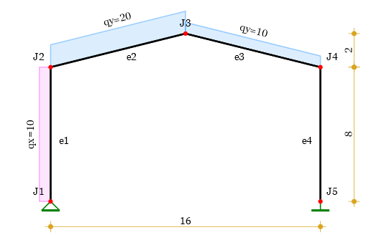
Materials
Modules of elasticity -
Poisson coefficients -
Shear modules -
Assignment on elements -
Cross-sections
Section S1 - - circular -
Section S2 - , - rectangular -
General representation -
Cross section properties
Equations
Area -
First moment of area -
Centroid -
Second moment of area -
First moment of area below z -
Shear area -
Calculated results
Centroids -
Areas -
Shear areas -
Second moments of area -
Assignment on elements -
Element stiffness matrix
Elastic properties for element "e"

,
Stiffness matrix coefficients for element "e"
, ,
,
Assembling the 3x3 stiffness matrix blocks for element "e"

Full 6x6 element stiffness matrix

Stiffness matrices obtained in local coordinates

Stiffness matrices obtained in global coordinates

Global stiffness matrix
It is formed by adding the 3x3 blocks of the element stiffness matrices to the 3x3 blocks in the global stiffness matrix with indices corresponding to the joint numbers at the ends of the respective elements.

Element load vector
Lateral load in local CS -
Axial load in local CS -
Equivalent loads at element endpoints
, ,
Load vector -
Results for elements
Element Е1 -
Element Е2 -
Element Е3 -
Element Е4 -
Global load vector

Results
Solution of the system of equations by Cholesky decomposition
= [1.88×10-19 -1.39×10-18 -0.000928 0.00809 -0.000126
-0.00274 0.0119 -0.0157 0.000699 0.0157 -9.84×10-5 0.000846 6.12×10-19
-1.09×10-18 -2.3×10-18 ]
Joint displacements
The displacements for each joint are extracted from the global vector:
,
Values for joints
u v φ·103
Joint J1 -
Joint J2 -
Joint J3 -
Joint J4 -
Joint J5 -
Support reactions
They are determined by multiplying the joint displacements by the respective spring constants.
, ,
Values for supports
Fx Fy M
Joint J1 -
Joint J5 -
Element end forces
Element endpoint displacements -
Endpoint forces are determined by multiplying the element stiffness matrix by the endpoint displacements in local CS and subtracting the element load vector values in local CS.

End forces values for different elements
Fx1 Fy1 M1 Fx2 Fy2 M2

Element internal forces
Axial forces - , kN
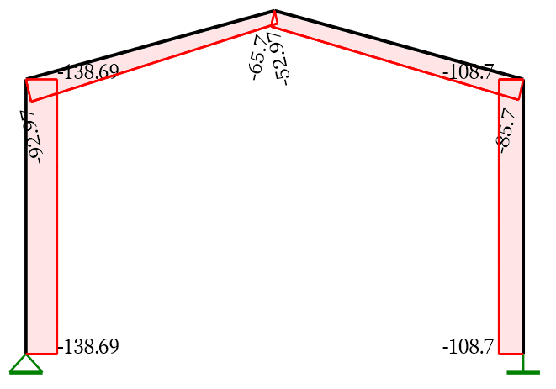
Shear forces- , kN
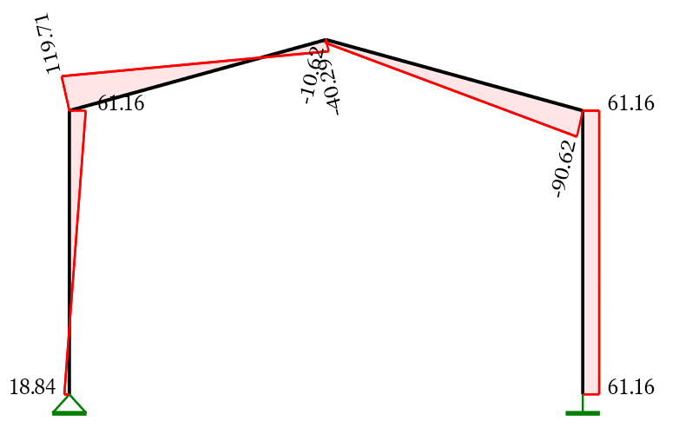
Bending moments- , kNm
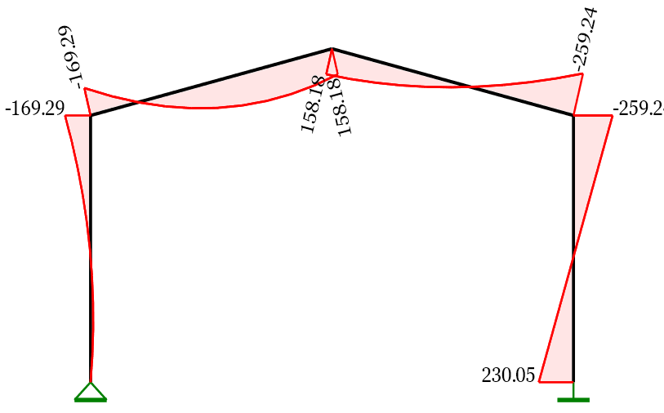
Deformed shape
Shape function in relative coordinates ξ = x/l (with account to shear deflections)

Element endpoint displacements and rotations

, ,
, ,
Displacement functions

Deformed shape, mm
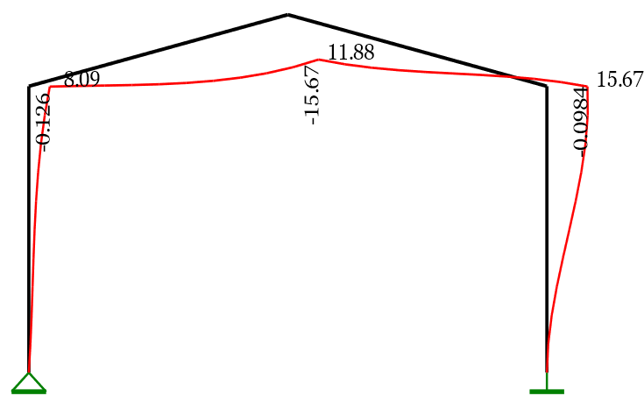

Comparison with Stadyps 6.0 software
Input data
Number of joints: 5 , Number of elements: 4
Joint coordinates
№ | X | Y | № | X | Y | № | X | Y | № | X | Y | № | X | Y
1 | 0.00 | 0.00 | 2 | 0.00 | 8.00 | 4 | 16.00 | 8.00 | 3 | 8.00 | 10.00 | 5 | 16.00 | 0.00
Materials
№ | Е | ν | α
1 | 45000000 | 0.200 | 0.000012
2 | 35000000 | 0.200 | 0.000012

Cross-sections
Section S1 - CIRCULAR
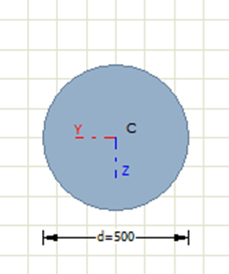 | d [mm] | C_{Z} [cm] | C_{Y} [cm] | A [cm²]
 | 500.0 | 25.0 | 25.0 | 1963.5
 | I_{Y} [cm⁴] | I_{Y} [cm] | W_{Y} [cm³] | I_{Z} [cm⁴] | I_{Z} [cm] | W_{Z} [cm³]
 | 306796 | 12.5 | 12271. | 306796 | 12.5 | 12271.
 | I_{t} [cm⁴] | W_{t} [cm³] | A_{qZ} [cm²] | A_{qY} [cm²]
 | 613592 | 24543. | 1767.1 | 1767.1

Section R1 - RECTANGULAR
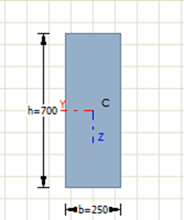 | b [mm] | h [mm] | C_{Z} [cm] | C_{Y} [cm] | A [cm²]
 | 250.0 | 700.0 | 35.0 | 12.5 | 1750.0
 | I_{Y} [cm⁴] | I_{Y} [cm] | W_{Y} [cm³] | I_{Z} [cm⁴] | I_{Z} [cm] | W_{Z} [cm³]
 | 714583 | 20.2 | 20416. | 91145. | 7.2 | 7291.7
 | I_{t} [cm⁴] | W_{t} [cm³] | A_{qZ} [cm²] | A_{qY} [cm²]
 | 282662 | 11767. | 1458.3 | 1458.3
Elements
№ | J₁ | J₂ | Type | Material | Section | ISZ | Winkl. Const.
1 | 1 | 2 | 3 | 1 | S1 | 0 | 0.0
2 | 2 | 3 | 3 | 2 | R1 | 0 | 0.0
3 | 3 | 4 | 3 | 2 | R1 | 0 | 0.0
4 | 4 | 5 | 3 | 1 | S1 | 0 | 0.0
Supports and springs
№ | Kxm | Kym | Kz | Kxy | Kxz | Kyz | Joints
4 | -1 | -1 | 0 | 0 | 0 | 0 | 1
7 | -1 | -1 | -1 | 0 | 0 | 0 | 5
Linearly distributed loads
№ | Type | q1 | q2 | A | L | Elements
1 | qx | 10.00 | 10.00 | 0.00 | 0.00 | 1
2 | qy | 10.00 | 10.00 | 0.00 | 0.00 | 2, 2, 3
Results
Joint displacements
Joint | Ux | Uy | Rz | Joint | Ux | Uy | Rz
1 | 0.000 | 0.000 | 0.001 | 2 | 0.008 | 0.000 | 0.003
3 | 0.012 | 0.016 | -0.001 | 4 | 0.016 | 0.000 | -0.001
5 | 0.000 | 0.000 | 0.000
Reactions in supports
Joint | Fx | Fy | Mz | Възел | Fx | Fy | Mz
1 | -18.839 | -138.687 | 0.000 | 5 | -61.161 | -108.700 | -230.046
Internal forces in elements
Element | Joint | M | N | Q | Joint | M | N | Q
1 | 1 | 0.00 | -138.69 | 18.84 | 2 | -169.29 | -138.69 | -61.16
2 | 2 | -169.29 | -92.97 | 119.71 | 3 | 158.18 | -52.97 | -40.29
3 | 3 | 158.18 | -65.70 | -10.62 | 4 | -259.24 | -85.70 | -90.62
4 | 4 | -259.24 | -108.70 | 61.16 | 5 | 230.05 | -108.70 | 61.16
Loads and support reactions, kN Axial forces, kN
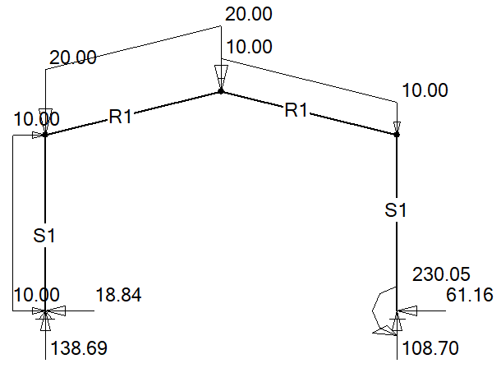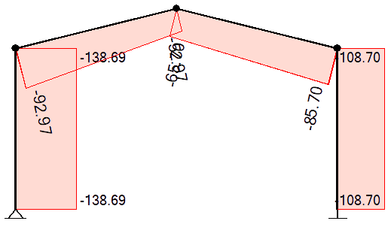
Shear forces, kN Bending moments, kNm
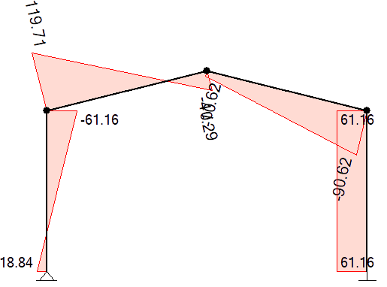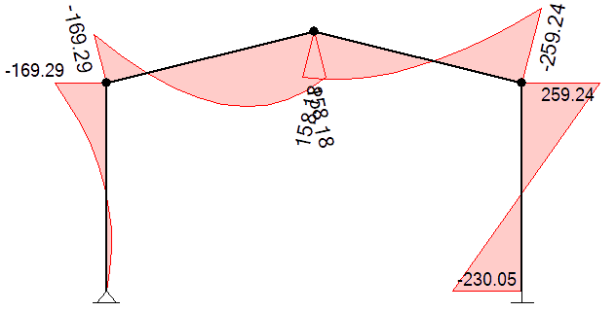
The results are almost identical.

